CHANDIGARH STATE AIDS CONTROL SOCIETY
INTERNATIONAL HOSTEL, SECTOR 15-A
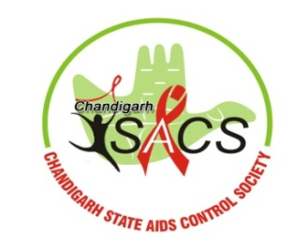
(NEAR PGIMER), MADHYA MARG, CHANDIGARH
PHONE NO. 2544563, 2783300, FAX No. 2700171
WEB SITE: www.chandigarhsacs.org.in
NOTICE INVITING BIDS
Bids (Online) are invited for the supply of ARV/OI Drugs. The detailed terms & Conditions can be obtained and downloaded from the website http://etenders.chd.nic.in/nicgep/app.
Bids can be downloaded online (Starting date) from 28.07.2025 at 11:00 AM to (end date) 19.8.2025 at 10:00 A.M. The decision of the office of Chandigarh State AIDS Control Society will be final.
Sd/-
Project Director
Chandigarh State AIDS Control Society

